**A PROJECT REPORT ON**

**UTILIZATION OF WASTE PLASTICS**



DIBENDU DAS

UDDIPTA JYOTI BHUYAN

NISHITA BURAGOHAIN

PRIYA SHREE HAZARIKA

**DEPARTMENT OF CHEMICAL ENGINEERING**

**ASSAM ENGINEERING COLLEGE**

**GUWAHATI-781013**

**MARCH,2022**

**UTILIZATION OF WASTE PLASTICS**

7th SEMESTER B.Tech. PROJECT

Submitted in partial fulfillment of the Requirements for the Degree of B.Tech. in CHEMICAL ENGINEERING

ASSAM ENGINEERING COLLEGE

By

DIBENDU DAS (18/296)

UDDIPTA JYOTI BHUYAN (18/329)

NISHITA BURAGOHAIN (19/531)

PRIYA SHREE HAZARIKA (19/534)



DEPARTMENT OF CHEMICAL ENGINEERING,

ASSAM ENGINEERING COLLEGE, GUWAHATI-781013,

MARCH 2022

**DEPARTMENT OF CHEMICAL ENGINEERING**

**ASSAM ENGINEERING COLLEGE**

**GUWAHATI‐781013**

This is to certify that Dibendu Das (18/296), Uddipta Jyoti Bhuyan (18/329), Nishita Buragohain (19/531), Priya Shree Hazarika (19/534) of B.Tech. 8th Semester have jointly carried out the project entitled **“Utilization of Waste Plastics**” under my supervision and submitted the report in partial fulfillment of the requirement for the Degree of B.Tech. in Chemical Engineering from Assam Engineering College.

Date: 09/03/2022 Dr. Shasanka Sekhar Borkotoky

Assistant Professor

Department of Chemical Engineering

Assam Engineering College

**DEPARTMENT OF CHEMICAL ENGINEERING**

**ASSAM ENGINEERING COLLEGE**

**GUWAHATI‐781013**

This is to certify that Dibendu Das (18/296), Uddipta Jyoti Bhuyan (18/329), Nishita Buragohain (19/531), Priya Shree Hazarika (19/534) of B.Tech. 8th Semester have jointly carried out the project entitled **“Utilization of Waste Plastics**” under my supervision and submitted the report in partial fulfillment of the requirement for the Degree of B.Tech. in Chemical Engineering from Assam Engineering College.

Date: 09/03/2022 Prof. Runjun Das

Head of the Department

Department of Chemical Engineering

Assam Engineering College

**DECLARATION**

We,

1. Dibendu Das, (18/296)

2. Uddipta Jyoti Bhuyan, (18/329)

3. Nishita Buragohain, (19/531)

4. Priya Shree Hazarika, (19/534)

sincerely declare that the project report titled “**Utilization Of Waste Plastics”** under the guidance of Dr. Shasanka Sekhar Borkotoky is submitted to the Chemical Engineering Department, Assam Engineering College in partial fulfillment of the requirements for the award of Bachelor of Technology degree in Chemical Engineering from Assam Engineering College.

We declare that this project has not been published previously elsewhere and is a result of our own efforts and has been taken solely for the academic purpose. All educational materials consulted in the course of study have been declared in the reference and all information provided in the project is true and correct to the best of our knowledge.

**ACKNOWLEDGEMENT**

We the students of B.Tech. 8th semester, Department of Chemical Engineering, Assam Engineering College would like to take this opportunity to extend gratitude to all the people associated with our project and thereby making us able to learn and understand the various perspectives of the project.

We extend our heartiest gratitude to Dr. Shasanka Sekhar Borkotoky, for providing us necessary inputs when needed. We would like to appreciate and acknowledge the efforts of our Chemical Engineering Department. In spite of their busy schedule, they were always eager to help us and share their vast experiences with us.

We would also like to thank the Academic Registrar of ASTU, Dr. B.R. Phukan for letting us use the laboratories in the ASTU premises and providing us with necessary input.

Last but not the least, we would like to thank our parents and family whose love and support, both on academic and personal front, has enabled us to see the light of this day.

**ABSTRACT**

This investigation has been carried out primarily to utilize waste plastics, specifically Polyethylene terephthalate (PET) and fabricate a useful waste PET-based nanocomposite film for different commodity applications. The primary focus of this work is to reduce the PET wastes along with their harmful impact in the environment. In the current investigation, we have collected the waste plastic bottles followed by cleaning and required pretreatments with subsequent drying. The waste plastic bottles are grinded into small pieces and their solubility in the different solvents is tested. Different parameters are taken and subsequent trial and error method is used to understand the effects of solvent in the solubility of the waste plastic. Process parameters such as temperature of heating, heating duration, quantity of solvent and PET chips are adjusted in order to fabricate a smooth and structurally sound film. We have taken Organically Modified Montmorillonite (OMMT) at different concentrations such as 1% and 2% to fabricate the waste PET-based nanocomposite films. The characterization of the fabricated waste PET-based films is carried out by utilizing Thermal Gravimetric Analysis (TGA) and Universal Testing Machine (UTM) in order to determine the thermal stability and ultimate tensile strength of the film. Improvement in the thermal stability of the film is observed on addition of OMMT nano-clay to the film. The film can be used as packaging or handling material which can handle up to 380°C without its properties being compromised. This investigation is helpful to understand the effects of OMMT in the waste PET-based films for their probable applications.

**LIST OF FIGURES**

|  |  |  |
| --- | --- | --- |
| **FIGURE NO.** | **FIGURE**  **TITLE** | **PAGE NO.** |
| Fig 1.1 | Plastics | 2 |
| Fig 1.2 | PET Bottles | 4 |
| Fig 2.1 | PET bottles to store soft drinks | 8 |
| Fig 2.2 | Formation of PET | 9 |
| Fig 2.3 | Polymeric Waste | 12 |
| Fig 2.4 | Dumping of Wastes in water bodies | 14 |
| Fig 3.1 | Collection of PET bottles | 19 |
| Fig 3.2 | Cut pieces of PET bottles | 24 |
| Fig 3.3 | Solubility of chips | 26 |
| Fig 3.4 | Film obtained through 1st set of parameters | 28 |
| Fig 3.5 | PET chips did not dissolve | 29 |
| Fig 3.6 | Proper film obtained | 30 |
| Fig 3.7 | Film obtained at lower temperature and increased heating duration | 31 |
| Fig 3.8 | Mixing of Nitrobenzene, MMT and chips | 33 |
| Fig 4.1 | TGA of the films | 38 |

Fig 4.2 Stress-Strain Curve of the PET Film 39

**LIST OF TABLES**

|  |  |  |
| --- | --- | --- |
| TABLE NO. | TITLE | PAGE NO. |
| 4.1 | Interaction of the chips with solvent | 36 |
| 4.2 | Optimum Parameters | 37 |
| 4.3 | Results from The Mechanical Test | 40 |

**NOMENCLATURE**

|  |  |
| --- | --- |
| PET | Polyethylene Terephthalate |
| DMSO | Dimethyl Sulfoxide |
| DCM | Dichloromethane |
| TGA | Thermal Gravimetric Analysis |
| MMT | Montmorillonite |
| POP | Persistent Organic Pollutants |
| DMA | Differential Mechanical Analysis |
| RPET | Recycled Polyethylene Terephthalate |
| PC | Polycarbonate |
| PVC | Polyvinyl Chloride |
| PS | Polystyrene |

**CONTENTS**

**CHAPTER PAGE NO**

Title Page i

Certification ii-iii

Declaration iv

Acknowledgement v

Abstract vi

List of Figures vii

List of Tables viii

Nomenclature ix

**CHAPTER 1:** INTRODUCTION

* 1. Introduction to Plastics 1
  2. Historical Background 2
  3. Objectives of The Study 3

**CHAPTER 2:** LITERATURE REVIEW

2.1 About Polymers 5

2.2 Properties of Polymers 5

2.3 Polyethylene Terephthalate 7

2.4 Advantages and Disadvatages of Polymers 9

2.5 Polymeric Waste 11

2.6 Solutions Towards Plastic Waste 16

**CHAPTER 3:** MATERIAL AND METHODS

3.1 Collection and Segregation of Waste Plastics 19

3.2 Cutting into Small Pieces 23

3.3 Pretreatment 24

3.4 Finding The Most Suitable Solvent 25

3.5 Adjusting Parameters 27

3.6 Additives Added to The Film 32

3.7 Tests Done on The Film 33

**CHAPTER 4:** RESULTS AND DISCUSSION

4.1 Results 33

**FUTURE SCOPE** 41

**CONCLUSION** 42

**REFERENCES**

**CHAPTER 1**

**INTRODUCTION TO PLASTICS**

* 1. **Introduction**

Modernization of a civilized society is dependent on the advancement of materials. Materials are the most important basic requirement for any civilization. The society as a whole is developing step by step with the development of materials from one category to the other. At present time polymers (plastic) are widely used in almost all the spheres of material applications. Production of plastic is an inevitable and global phenomenon. Around 400 million tons of plastics are produced annually worldwide. End stage of plastic disposal contaminates the waterways and aquifers, it limits the landfill areas that generate odors, harmful gases and other hydrocarbons while incineration.

In 2015, about 55% of global plastic waste was discarded, 25% was incinerated, and 20% recycled. [1] Annual Australian plastics recycling in 2016–17 was 415200t at recycling rate of 11.8%. In accordance to Plastics Europe, for the first time, recycling (31.1%) overcame landfill (27.3%) in 2016.From the year 2006 to 2016, the volumes of plastic waste collected for recycling had an increment by 79%, increase of energy recovery by 61% and landfill decreased by 43%.[1]

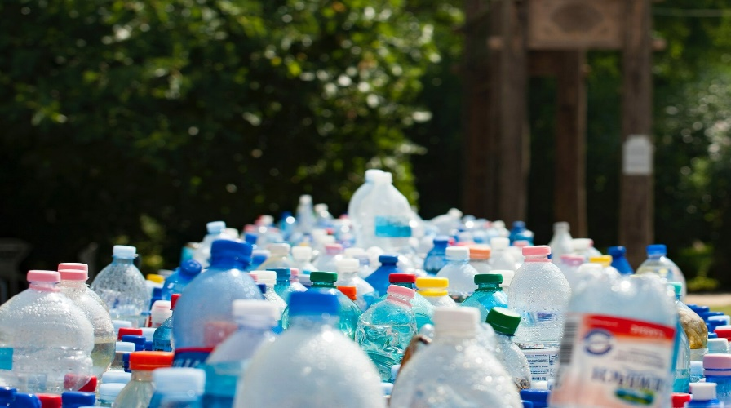

Fig 1.1: Plastics

Use of plastic cannot be banned, but we can reuse it in many ways. Plastic are reusable in various sectors like marketing, manufacturing, transportation etc. Even in construction sector, we can use the plastic waste on a very large scale after recycling it, which means the problem of plastic waste can be removed for a long time period. It seems to be more practicable and efficient method to solve this problem.

* 1. **Historical Background**

The word ‘plastic’ originally meant “pliable and easily shaped.” It became a name for a category of materials called polymers. The word polymer means “of many parts,” and polymers are made of long chains of molecules. Polymer has started its journey way back to the starting of life in the universe which is seen in the fascinating process of combination of elements like carbon, hydrogen, oxygen, nitrogen, etc. into protein, cellulose, starch, etc. In 1833, ‘polymer’ term was first coined by J.J. Berzelius. Aside from significant advances in synthesis and characterization of different polymers until 1920s, the realization of the concept of macromolecules as given by H. Staudinger is the real turning point of the polymer. In 1920s, W. Carothers in 1920s also demonstrated that polymers could be synthesized rationally from their constituent monomers. Although the concept is very important but the composition, arrangement, and spatial disposition of the units in the polymer chains are more important parameters to know about their structures. Another important contribution to synthetic polymer science was made by the Italian chemist G. Natta and the German chemist K. Ziegler who won the Nobel Prize in Chemistry in 1963 for Hence, methods to recycle PET bottle waste have been look into in order to improve PET recycling applications. In construction projects, the usage of PET plastic fibers recycled from PET bottle waste has been actively studied. Fibers such as short PET fibers can be utilized to reduce shrinkage strain effectively and to increase ductility of concrete, in order to mitigate the inherent shrinkage problem of concrete. The development of the Ziegler-Natta catalyst, based on which many important polymers have been developed. Since then a large number of useful polymers have been developed in the history of polymer.

**1.3 Objectives of The Study**

The reputation of plastic fell further in the 1970’s and 1980’s as waste production began to increase. It became a special target since so many plastic products are disposable and it last forever in the environment. Polymeric matrices are divided into thermoplastics and thermo sets. Thermoplastics undergo chemical, thermal, photo-, or biodegradation and can be transformed or repolymerized into new products. However, the challenge is to ensure material performance during its useful lifetime and is not compromised during the end-of-life degradation and/or reprocessing.

Polyethylene terephthalate (PET) is the most extensively used plastic material in the world for production of secondary products such as beverage bottles. Nevertheless, PET bottles are usually thrown away after single usage, which adds environmental problems.

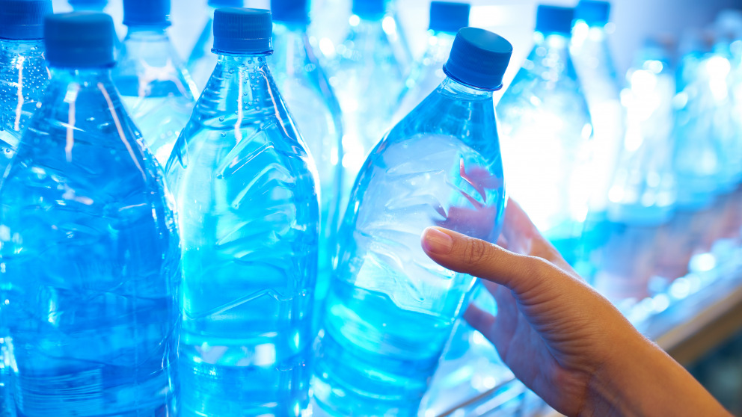

Fig 1.1 : PET Bottles

**CHAPTER 2**

**LITERATURE REVIEW**

**2.1 About Polymers**

The word polymer denotes molecule made up by the repetition of some simpler unit known as monomer. The number of monomers within the polymer molecule can change greatly, and the extent to which regularity appears in the order, relative orientation, and the presence of differing monomers within the same polymer molecule can differ as well. In many man-made and some natural polymers, the number of monomers (can also be referred to as the degree of polymerization) can be found exactly, often in order to tailor the properties of the material.

**2.2 Properties of Polymer**

**2.2.1 Crystallization and Melting**

Polymers may be either semi-crystalline or amorphous, depending on their chemical structures. Semi-crystalline polymers can form crystallization and melting transitions, while amorphous polymers do not. In polymers, crystallization and melting does not indicate solid-liquid phase transitions, as such the case of water or other molecular fluids. Alternatively, crystallization and melting mentions the phase transitions between two solid states (i.e., semi-crystalline and amorphous). Crystallization occurs above the glass-transition temperature (Tg ) and below the melting temperature (Tm).

**2.2.2 Glass Transition Temperature**

All polymers (amorphous or semi-crystalline) undergo glass transitions. The glass transition temperature (Tg ) is a crucial physical parameter for polymer manufacturing, processing, and use. Below Tg , molecular motions are frozen and polymers are brittle and glassy. Above Tg , molecular motions are activated and polymers are rubbery and viscous. The glass-transition temperature may be caused by altering the degree of branching or crosslinking in the polymer or by the addition of plasticizers. However crystallization and melting are first-order phase transitions, while the glass transition is not. The glass transition shares features of second-order phase transitions (such as discontinuity in the heat capacity, as shown in the figure), but it is generally not considered a thermodynamic transition between equilibrium states.

**2.2.3 Chemical Properties**

The attractive forces between polymer chains play a huge role in finding the polymer’s properties. As polymer chains are so long, there involves interchain interactions per molecule, that amplifies the effect of these interactions on the polymer properties in contrary to attractions between conventional molecules. Different side groups on the polymer can give the polymer to ionic bonding or hydrogen bonding between its own chains. These stronger forces typically effect in higher tensile strength and higher crystalline melting points. The dipoles in the monomer units can be affected by intermolecular forces in polymers. Polymers having non-polar units such as polyethylene interact only through weak Van der Waals forces. As a result, they have lower melting temperatures than other polymers. Overall, the chemical properties of a polymer are important elements for designing new polymeric material products.

**2.2.4 Optical Properties**

The behavior of polymer on interaction of light energy is called optical property. Refractive index, transparency, haziness, color, transmittance, reflectance are important optical properties of the polymer. Generally amorphous polymers, free from any type of impurities or additives are transparent, provided no visible no visible light absorbing functional group is present in the structure. Examples: PMMA, bisphenol etc.

**2.2.5 Electrical Properties**

The ability of a material to flow or oppose current under applied external filed is called electrical properties. Most of the polymers are insulators. This is due to covalent nature of polymer as well as absence of adequate free electron. The insulating characteristic of polymer are less affected by the presence of imperfection or impurities than ceramics.

**2.3 Polyethylene Terephthalate**

PET or poly(ethylene terephthalate)is the most common thermoplastic polymer resin of the polyester family and is used in fibers for clothing, containers for liquids and foods, and thermoforming for manufacturing, and in combination with glass fiber for engineering resins.

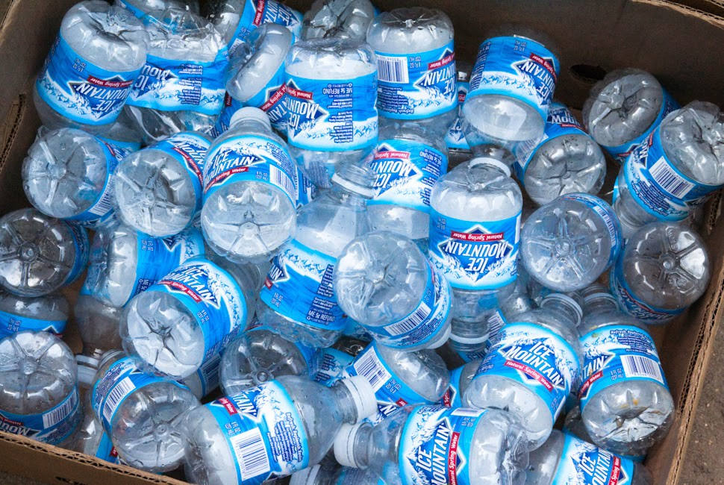

Fig 2.1 : PET bottles to store soft drinks

In 2016, annual production of PET was 56 million tons.[1] The biggest application is in fibers (in excess of 60%), with bottle production accounting for about 30% of global demand. [1] In the context of textile applications, PET is referred to by its common name, polyester, whereas the acronym PET is generally used in relation to packaging. Polyester makes up about 18% of world polymer production and is the fourth-most-produced polymer after polyethylene (PE), polypropylene (PP) and polyvinyl chloride (PVC).

PET is produced by the polymerization of ethylene glycol and terephthalic acid. Ethylene glycol is a colorless liquid obtained from ethylene, and terephthalic acid is a crystalline solid obtained from xylene. When heated together under the influence of chemical catalysts, ethylene glycol and terephthalic acid produce PET in the form of a molten, viscous mass that can be spun directly to fibers or solidified for later processing as a plastic. In chemical terms, ethylene glycol is a diol, an alcohol with a molecular structure that contains two hydroxyl (OH) groups, and terephthalic acid is a dicarboxylic aromatic acid, an acid with a molecular structure that contains a large six-sided carbon (or aromatic) ring and two carboxyl (CO2H) groups. Under the influence of heat and catalysts, the hydroxyl and carboxyl groups react to form ester (CO-O) groups, which serve as the chemical links joining multiple PET units together into long-chain polymers.

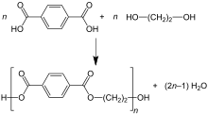

Fig 2.2: Formation of PET

PET is a clear, strong, and lightweight plastic that is widely used for packaging foods and beverages, especially convenience-sized soft drinks, juices and water. Virtually all single-serving and 2-liter bottles of carbonated soft drinks and water sold in the U.S. are made from PET. It is also popular for packaging salad dressings, peanut butter, cooking oils, mouthwash, shampoo, liquid hand soap, window cleaner, even tennis balls. Special grades of PET are used for carry-home food containers and prepared food trays that can be warmed in the oven or microwave.

**2.4 Advantages and Disadvantages of Polymer**

**2.4.2 Advantages**

1.Lightweight:Polymer and composite materials are up to ten times lighter than typical metals. A reduction in the weight of parts can have a huge impact on an aerospace company’s bottom line. For every pound of weight reduced on a plane, the airline can realize up to $15k per year in fuel cost reduction.

2.Corrosion-Resistant:Plastic materials handle far better than metals in chemically harsh environments. This increases the lifespan of the aircraft and avoids costly repairs brought about by corroding metal components an in-turn reducing MRO downtime provides for more operational time per aircraft per year.

3.Insulating and Radar Absorbent:Polymers are naturally radar absorbent as well as thermally and electrically insulating.

4.Flame & Smoke Resistances:High-performance thermoplastics meet the stringent flame and smoke resistances required for aerospace applications.

5.Sterility:In the medical industry, cleanliness is vital when it comes to equipment. Infection is the greatest threat facing hospital patients. Polymer and composite materials are easier to clean and sterilize than metal.

**2.4.1 Disadvantages**

1. Food Imitation: One of the most common environmental problems associated with synthetic polymers pollution is that 44 percent of seabird species are known to have ingested synthetic polymers that have been mistaken for food, according to the U.S. National Institutes of Health with millions dying from this ingestion every year. This broad reaching death of shore birds presents a significant environmental problem because shorebirds play a vital ecological role in maintaining the population sizes of fish and crustaceans.

2. Problems Related to its production: Beyond its evident pollution of oceans, synthetic polymers can also present environmental problems in the process of their production. The Environmental Working Group organization shows that the DuPont chemical company leaked contaminates used in their production of Teflon into local watersheds for several decades. According to the U.S. Environmental Protection Agency, this chemical accumulates in the gills of fish and can travel in high quantities up the food chain.

3. Landfill Accumulation: Even beyond their persistence in oceans and water pollution from their production, synthetic polymers are a significant challenge on land because they are often disposed of in landfills where they will remain for centuries into the future slowly leaking toxins into soil as time passes. According to the Clean Air Council organization, Americans alone use an estimated 102.1 billion plastic bags -- a synthetic polymer -- each year, and less than 1 percent of these bags are recycled. Not only do these synthetic polymers slowly leach harmful chemicals in the soil, their longevity and non-biodegradability means new landfills will be a constant need as synthetic polymer use continues and grows.

**2.5 Polymeric Wastes**

Plastic waste, or plastic pollution, is the ‘the accumulation of plastic objects (e.g.: plastic bottles and much more) in the Earth’s environment that adversely affects wildlife, wildlife habitat, and humans.’ It also refers to the significant amount of plastic that isn’t recycled and ends up in landfill or, in the developing world, thrown into unregulated dump sites. In the UK, for example, over 5 million tons of plastic is consumed each year- and yet only 1 quarter of it is recycled. The three quarters that isn’t recycled enters our environment, polluting our oceans and causing damage to our ecosystem. In less developed countries, the majority of plastic waste eventually ends up in the ocean, meaning that marine animals are especially at risk. So much of what we consume is made of plastic(such as plastic bottles and food containers) because it’s inexpensive, yet durable. However, plastic is slow to degrade (taking over 400 years or more) due to it’s chemical structure, which prevents a huge challenge.

Reducing plastic consumption and raising awareness about plastic recycling is crucial if we are to overcome the problem of plastic waste and pollution on our planet.

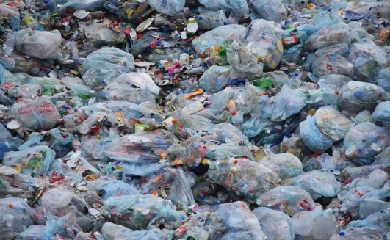

Fig 2.3 : Polymeric Wastes

Plastic waste in our oceans is a global problem, but how does our rubbish enter the water in the first place? In many cases, specifically in more developed countries, plastic waste is disposed of responsibly and sent to facilities to be sorted, recycled or recovered. However, plastic waste generated in developing countries typically ends up in open unregulated dumpsites, or is thrown into rivers and streams. Plastics from dumpsites can be blown by winds into bodies of water, such as nearby rivers, before being carried out to sea. Another problem is the volume of plastic that is exported to developing nations from Europe, the US, and Japan. Recycling standards in developing countries do not compare to standards deployed in the developed world and, as such, releasing plastics into the environment is causing significant environmental damage.

Each year, approximately eight million tons of plastic ends up in our oceans. Some researchers predict that this figure could double by 2025, while others suggest there could be more plastic than fish in our oceans by 2050. Over time, ocean currents pull rubbish into the center, resulting in huge gyres of plastic developing (the largest is in the North Pacific, between Hawaii and California, which contains 1.8 trillion pieces of plastic). Eventually, this pulling motion in the gyre causes plastic objects to break down into multiples smaller pieces, polluting the environment and making plastic waste easily swallowed by marine animals.

**2.5.1 Effect of Plastic Waste on Marine Life**

According to the United Nations, ‘at least 800 species worldwide are affected by marine debris, and as much as 80 percent of that litter is plastic. ‘Marine animals can either get caught in plastic objects (such as the plastic rings that hold drinks cans together), ingest the plastic, and/or be exposed to plastic chemicals, which can alter their physiology over time. A recent study found that ‘sea turtles that ingest just 14 pieces of plastic have an increased risk of death.’ In particular, young turtles are at a higher risk because they tend to drift with the same currents that attract plastic waste, and they are less selective than their elders about what they eat.

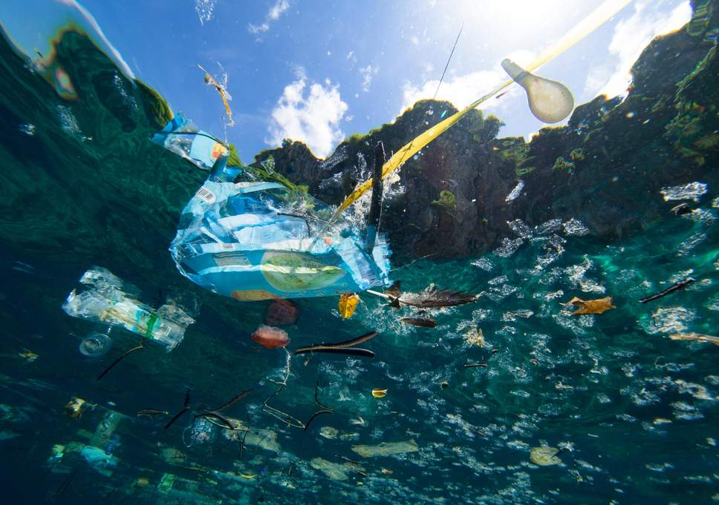

Fig 2.4 : Dumping of wastes in water bodies

Plastic micro-beads, which are commonly found in toiletries such as facial scrubs, toothpastes, and shower gels can also wreak havoc on marine life. Most sewage treatment facilities cannot capture these beads from incoming sewage and so they are discharged directly into water courses. The BBC explains that ‘They do not degrade over time and can transport toxic chemicals into marine organisms.’

Fortunately, the UK banned the sale of products containing plastic microbeads in July 2018. However, the BBC also states that ‘Some countries and states have loopholes that allow microbeads made from biodegradable plastic to continue to be used’. In other words, there’s still a lot of work to be done.

**2.5.2 Estimation of Plastic Waste Around the World**

Six decades ago, mass production of plastics began accelerating so rapidly that it has created 8.3 billion tons of plastic and over 90% of it isn’t recycled.

As of 2018, approximately 380 million tons of plastic is produced worldwide each year. Our planet can’t cope with this amount of plastic polluting the environment, and calls to reduce plastic pollution and consumption have increased in urgency in recent years.

**2.5.2 Prime Causes of Plastic Waste**

1. Plastic is cheap, readily available, and its use is widespread. Since plastic is an affordable and durable material, it can be found in everything from packaging materials to plastic bottles, straws to plastic bags, and much more. Until businesses start to utilize more environmentally-friendly, alternative materials (such as paper), the cycle of producing and disposing of plastic will continue.

2. Due to increase in population: Put simply, the more of us there are in the world, the greater the demand for cheap materials and in turn, the more plastic we use to excess. To illustrate this, in the first decade of this century, more plastic has been produced than ever due to rapid urbanization and, in turn, demand.

3. Due to disposable mentality: Plastic items typically have a very short lifespan such as carrier bags, water bottles, straws, and food containers. And because they’re so cheap to make, we don’t value them enough to hang on to individual items. Not only that, but the disposal of plastic is often mismanaged so again, it ends up in landfills.

4. Plastic takes over 400 years to decompose: The chemical bonds that make-up plastic are strong and made to last. The decomposition rate of plastic can vary depending on the type, however, this typically ranges from 50 to 600 years. In other words, according to the US EPA (Environmental Protection Agency in the United States), almost every bit of plastic ever made and sent to landfill or dumped in the environment still exists . As new plastic items are manufactured every day, the cycle repeats.

5. Marine shipping and fishing industries: The shipping and fishing industries are also responsible for contributing towards plastic waste and pollution, particularly in our oceans. Plastic waste is often washed to shores from ships and nets used for fishing, which — you guessed it — are usually made from plastic. Not only does this plastic pollute the water, but marine animals can become trapped in nets and/or swallow the toxic particles. Overall, the shipping and fishing industries have a lot to answer for when it comes to plastic pollution.

**2.5.3 Solution Towards Plastic Wastes**

1.Landfilling: Landfill is the conventional approach to waste management, but space for landfills is becoming scarce in some countries. In a landfill, (with portions of MSW), as waste breaks down methane is generated. This gas can be recovered and used to generate electricity. Plastic waste creates an eternal problem as plastic products synthesized from petroleum are not biodegradable. For this reason, plastic waste remains in landfills, without breaking down or changing composition.

2.Incineration: Incineration reduces the need for landfill of plastics waste, however, there are concerns that hazardous substances may be released into the atmosphere in the process. Incineration can be used with recovery of some of the energy content in the plastic. When the plastics disposed to landfill/sewage/marine water, they do not degrade and biodegrade, and generally it takes more than 100 years to degrade under natural conditions. Incineration and pyrolysis techniques are not successful for plastic wastes now a days.

3. Construction of polymer (plastics) coated bitumen road: Initially the plastic wastes are collected, segregated and sent to storage. Then they are cleaned and dried. After drying is done, the plastic wastes are shredded into size (2-4 mm). Then the coated aggregate is mixed with hot bitumen at temperature ranges from (155-163)℃. The shredded polymeric waste(5-10% w/w) is added to heated stone aggregate for (30-40) sec and then mixed for uniform coating at surface of aggregate. The stone aggregate (granite, ceramic) heated to around (160-170)℃. The mix (composite) known as waste plastic-aggregate bitumen mix (130-140)℃. This composite used for road laying at temperature between (110-130)℃.

4. Plasma Pyrolysis Technology: Pyrolysis is the thermal disintegration of carbonaceous material in oxygen-starved atmosphere. The intense and versatile heat generation capabilities of Plasma Pyrolysis technology enable to dispose of all type of plastic waste including polymeric, biomedical and hazardous waste in a safe and reliable manner. When optimized, the most likely compounds formed are methane, carbon monoxide, hydrogen, carbon dioxide and water molecules.

5. Conversion into Liquid Fuel: The entire process is undertaken in closed reactor vessel followed by condensation, if required. Waste plastics while heating up to 2700 to 3000℃ convert into liquid-vapor state, which is collected in condensation chamber in the form of liquid fuel. The tarry liquid waste is topped-down from the heating reactor vessel. The organic gas is generated which can be used in dual fuel diesel generator set for generation of electricity.

**CHAPTER 3**

**MATERIAL AND METHODS**

**3.1 Collection and Segregation of Waste Plastics**

Waste plastic bottles were collected mostly from nearby shops and restaurants. We also collected waste plastic bottles from nearby dump sites. For these the waste PET bottles had to be segregated form other wastes thrown in the dump site. Since the scale of our project was small so we could separate the required pet bottles from the unnecessary wastes by hand. But when the scale is large or recycling has to be done in a commercial or industrial scale then segregation of plastic bottles from other wastes becomes a cumbersome task.

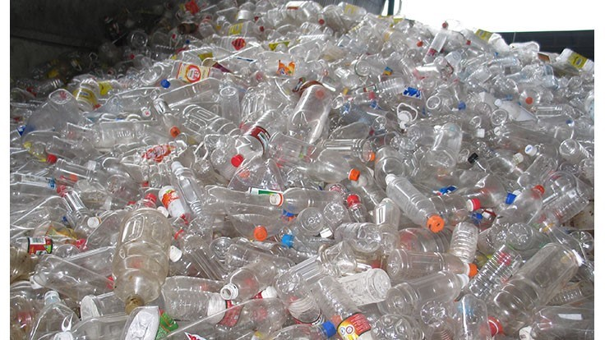

Fig 3.1 : Collection of PET bottles

The empty PET packaging is discarded by the consumer, after use and becomes PET waste. In the recycling industry, this is referred to as "post-consumer PET." Many local governments and waste collection agencies have started to collect post-consumer PET separately from other household waste. Besides that there is container deposit legislation in some countries which also applies to PET bottles. Under container deposit legislation when customers return their waste bottles, their initial deposit on those bottles is partially or fully refunded.

In the United States, there are two primary methods for recovery of PET bottles and containers. The first is curbside recycling to which most consumers have access. The waste hauler brings the recycled material to a material recovery facility (MRF) where it is further separated. The PET is then baled and sent on to a PET reclaimer. The PET reclaimer processes the bale, grinding the PET into flakes. Some do additional processing to make ready for food grade packaging.

When the PET bottles are returned to an authorized redemption center, or to the original seller in some jurisdictions, the deposit is partly or fully refunded to the redeemer. In both cases the collected post-consumer PET is taken to recycling centers known as materials recovery facilities (MRF) where it is sorted and separated from other materials such as metal, objects made out of other rigid plastics such as PVC, HDPE, polypropylene, flexible plastics such as those used for bags (generally low density polyethylene), drink cartons, glass, and anything else which is not made out of PET.

Post-consumer PET is often sorted into different color fractions: transparent or uncolored PET, blue and green colored PET, and the remainder into a mixed colors fraction. The emergence of new colors (such as amber for plastic beer bottles) further complicates the sorting process for the recycling industry.

The sorted post-consumer PET waste is crushed, pressed into bales and offered for sale to recycling companies. Colorless/light blue post-consumer PET attracts higher sales prices than the darker blue and green fractions. The mixed color fraction is the least valuable due simply to the fact unlike aluminum, there are few standards when it comes to the coloration of PET. Unlike clear varieties, PET with unique color characteristics are only useful to the particular manufacturer that uses that color. For material recovery facilities, colored PET bottles are therefore a cause for concern as they can impact the financial viability of recycling such materials. The Plastics Recyclers Europe (PRE, Brussels, Belgium), that an upsurge in a variety of PET colors would be a problem because no market exists for them in the current recycling climate.

The further treatment process includes crushing, washing, separating and drying. Recycling companies further treat the post-consumer PET by shredding the material into small fragments. These fragments still contain residues of the original content, shredded paper labels and plastic caps. These are removed by plastic granulation, resulting in pure PET fragments, or "PET flakes". PET flakes are used as the raw material for a range of products that would otherwise be made of polyester. Examples include polyester fibres (a base material for the production of clothing, pillows, carpets, etc.), polyester sheets, strapping, or back into PET bottles.

Melt filtration is typically used to remove contaminants from polymer melts during the extrusion process. There is a mechanical separation of the contaminants within a machine called a ‘screen changer’. A typical system will consist of a steel housing with the filtration medium contained in moveable pistons or slide plates that enable the processor to remove the screens from the extruder flow without stopping production. The contaminants are usually collected on woven wire screens which are supported on a stainless-steel plate called a ‘breaker plate ‘a strong circular piece of steel drilled with large holes to allow the flow of the polymer melt. For the recycling of polyester it is typical to integrate a screen changer into the extrusion line. This can be in a pelletizing, sheet extrusion or strapping tape extrusion line. PET polymer is very sensitive to hydrolytic degradation, resulting in severe reduction in its molecular weight, thereby adversely affecting its subsequent melt processability. Therefore, it is essential to dry the PET flakes or granules to a very low moisture level prior to melt extrusion. PET must be dried to <100 parts per million (ppm) moisture and maintained at this moisture level to minimize hydrolysis during melt processing.

Flotation, as one efficient waste plastic separation technology, is an effective method to improve the recycling rate of packaging waste. Polyethylene terephthalate (PET) widely used in packaging industry, has a large number of consumption and high recovery value. Aiming at separating PET from plastic packaging wastes, a designed flotation column was used in laboratory to investigate the effects of parameters, such as wetting agent species and wetting agent concentration, on the flotation behaviors. The results showed that the primary flotation of PVC/PET/PC/PS achieved the optimal effect with PS as floating materials and PET/PC/PVC sinking materials under 70 mg/L of sodium dodecyl sulfate as wetting agent. When 3 mol/L sodium hydroxide used to modify the mixed plastics and 8mmol/L of dibutyl sebacate (DBS) used as wetting agent, PET/PC/PVC separation in the secondary flotation achieved the optimal effect with PET floating rate being 3.56% and PC/PVC floating rate being 97.45% and 92.91% respectively. After two stages of flotation screening, the purity of recycled PET finally reached 90.91%, which indicated that the flotation process developed could effectively separate PET from four kinds of mixed plastics.

**3.2 Cutting of Pet Bottles into Small Pieces**

After the segregation of waste pet bottles from other plastics and the subsequent removal of their caps and stickers we washed the PET bottles with water to remove sand, dirt or any other impurities present. They were then left to dry at room temperature for 24 hours.

To make it easier for the solvent to break the inter-molecular bonds of PET, we cut the plastic pieces into small chips with the help of scissors.

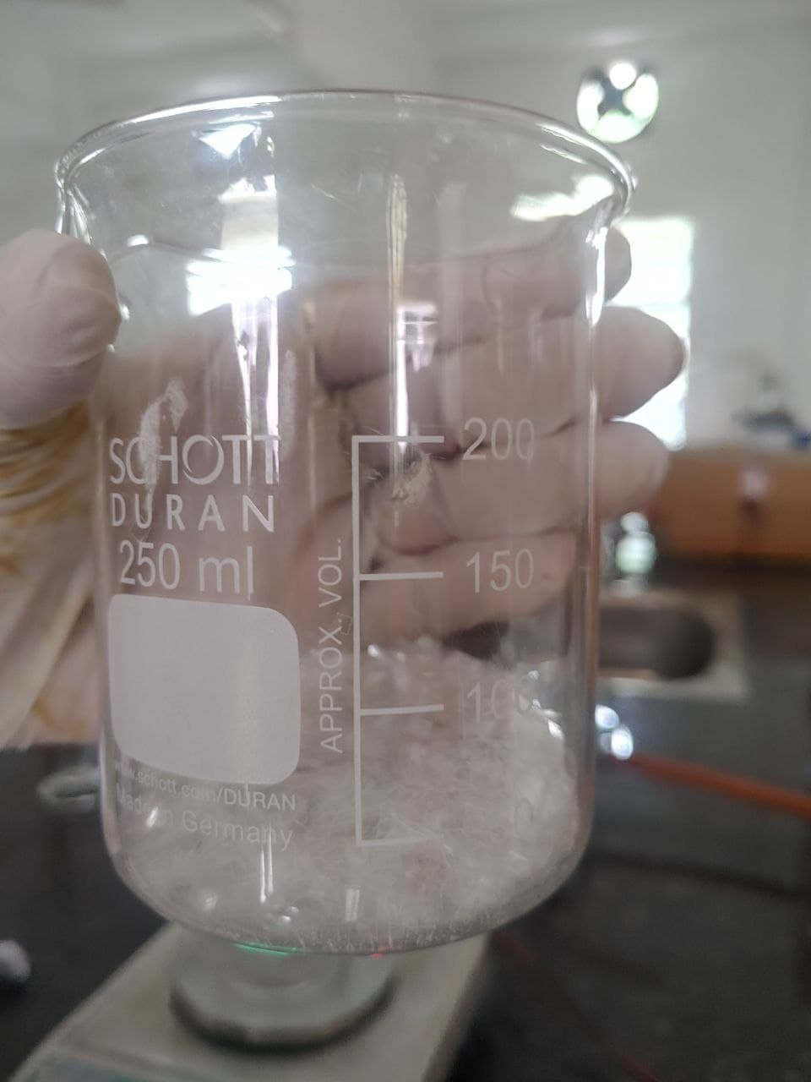

Fig 3.2 : Cut pieces of PET bottles in a beaker

In industries the processes to make PET bottle flakes from collected bottles are as versatile as the different waste streams are different in their composition and quality. In view of technology there is not just one way to do it. Meanwhile, there are many engineering companies that are offering flake production plants and components, and it is difficult to decide for one or other plant design. Nevertheless, there are processes that are sharing most of these principles.

A general process by which pellets are formed in industries from recycled pet bottles is as follows: The bottles that are collected from various waste streams are compressed into bales and are transported to recycling plants. The bales are fed into a machine that breaks it apart and any metal pieces present are separated in this step. Other types of plastic are removed before the remaining pet is color sorted by hand. Each color is separated into its color stream and then crushed into small flakes. The flakes still contain labels, rings and ground up lids. They are all separated from the PET in the washing process. Washing also remains contaminants like glue leaving behind clean, clear pet flakes. The flakes are dried, extruded and cooled and then chopped into small pieces. Finally gem like pellets are formed which are ready to be used in different industries.

**3.3 Pretreatment**

After the PET bottles were cut into small chips, they were then dipped into a Toluene solution for pretreatment. They were kept submerged in the toluene solution for about 10 minutes. They were then separated or sieved from the solvent using a tea strainer and left to dry at room temperature for 24 hours.

**3.4 Finding the Most Suitable Solvent**

The solubility of the plastic chips was tested against different solvents at fixed temperatures. For the test 20 ml of solvent was taken along with 6 gm of polymer/plastic/PET chips.

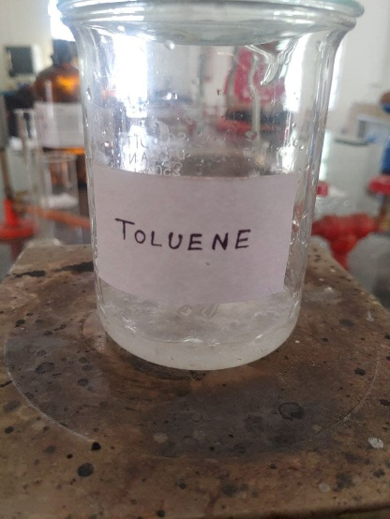

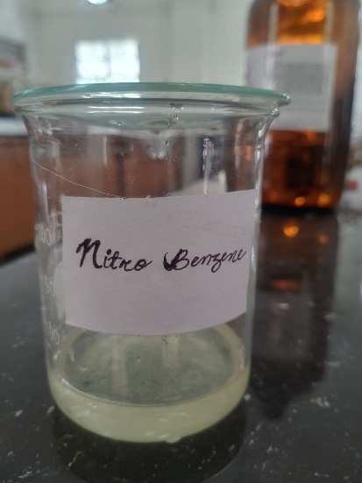

Fig 3.3 : Solubility of chips in different solvents

The tests were first done at room temperature and then the solubility was checked at elevated temperatures. The PET chips and the solvent were taken in a borosilicate beaker and stirred continuously at room temperature. For checking at elevated temperatures, the borosilicate beaker was put in a oven and the desired temperature was set in the oven. The ideal situation would be the plastic chips dissolving in the solvent at room temperature. This would save a lot of energy and money as no heating equipment would be required. It would also save time and increase the productivity. The solubility of the solvents was checked through visual observation and by filtering of the solution using a tea strainer. The plastic pieces swelled in both nitrobenzene and phenol at 100°C. Phenol as a solvent was abandoned because exposure to phenol may cause irritation to the skin, eyes, nose, throat, and nervous system. Severe exposure can cause liver and/or kidney damage, skin burns, tremor, convulsions, and twitching. As a corrosive substance, phenol denatures proteins and generally acts as a protoplasmic poison. Phenol may also cause peripheral nerve damage. Systemic poisoning can occur after inhalation, skin contact, eye contact, or ingestion. Nitrobenzene is relatively less toxic and hence was selected as the solvent.

**3.5 Adjusting Parameters to Obtain a Suitable Pet Film**

**3.5.1 Adjusting Parameters to Uniformly Dissolve the Chips**

1. Plastic Chips = 7 gm; Nitrobenzene = 40 ml; Temperature = 156°C; time = 30 minutes.

The chips were not dissolved uniformly and a rough textured mass was obtained in the casted solution. The casted solution was kept in room temperature for 2 days but the solvent did not evaporate. So the solution was heated back in the oven till 180°C and then kept at room temperature for 24 hours and a film of considerable strength and thickness was obtained. It was further heated till 160°C but significant change in structure or texture was seen.

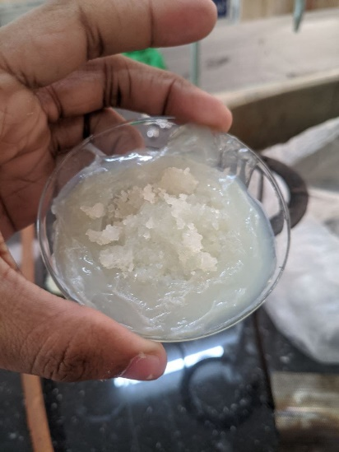

Fig 3.4: Film obtained through 1st set of parameters

1. Plastic Chips = 5 gm; Nitrobenzene = 20 ml; Temperature = 180°C;time = 30 minutes.

The chips did not dissolve at all. The viscosity of the solvent remain same and the texture of the chips did not change. The amount of solvent taken was not enough to dissolve the chips.

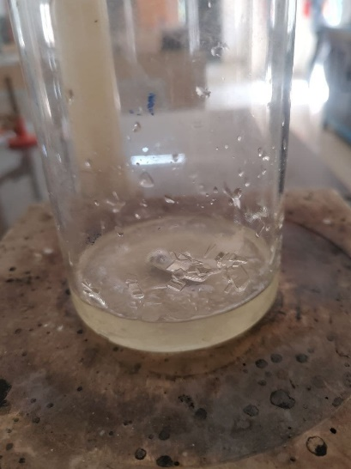

Fig 3.5 : PET chips did not dissolve

1. Plastic Chips = 5 gm; Nitrobenzene = 50 ml; Temperature = 160°C; time = 15 minutes.

The chips did not dissolve at all. The duration of heating was too low in this case.

1. Plastic Chips = 5 gm; Nitrobenzene = 50 ml; Temperature = 180°C; time = 30 minutes.

The chips dissolved uniformly and a proper film was obtained after separating the solvent.

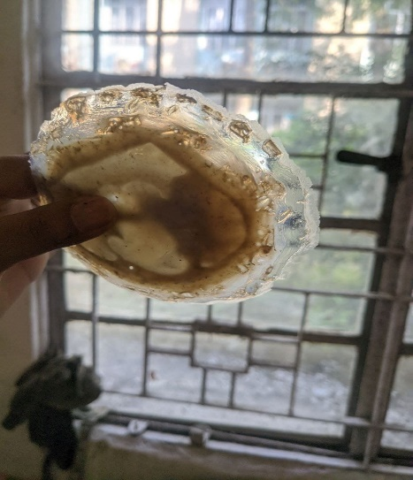

Fig 3.6 : Proper film obtained

1. Plastic Chips = 6 gm; Nitrobenzene = 40 ml; Temperature = 165°C;time = 45 minutes.

Here the parameters were adjusted to make the set temperature lower and to decrease the amount of solvent being used. The heating time was extended to 45 minutes. A proper film was obtained with good strength and rigidity.

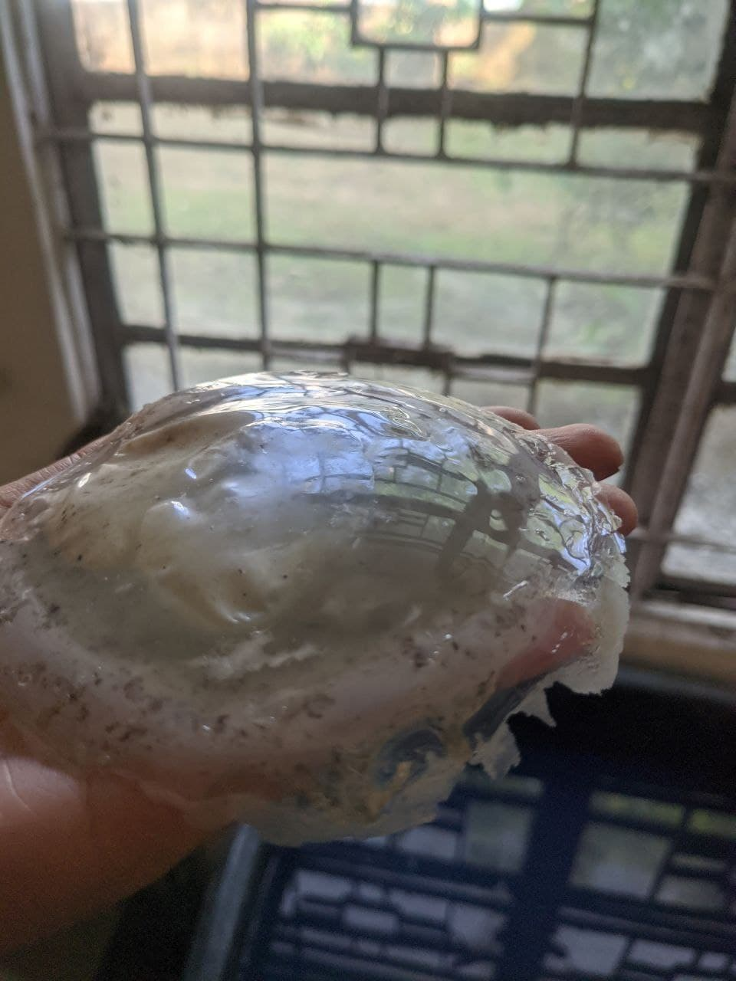

Fig 3.7: Film obtained at lower temperature and increased heating duration

**3.5.2 Separation of The Solvent from The Film**

The solvent did not separate from the film at room temperature. The film was to be further heated in the oven to separate the solvent. We heated the film at 210°C for 120 mins which is the boiling point of the solvent (Nitrobenzene). But considerable amount of solvent was still present in the film. So on the next run the temperature was set at 220°C and it was heated for 90 mins. Negligible amount of solvent was present at this stage. Another problem encountered due to heating at high temperatures was the film sticking to the surface of the Petri dish. It was impossible to separate the film from the Petri dish without breaking the Petri dish. Hence we employed castor oil and aluminum foil on the petri dishes on two separate samples respectively. The aluminum foil could not withstand the high temperatures but the application of castor oil on the petri dish helped in separating the film from the petri dish.

**3.5.3 Selected Procedure and Parameters**

6 gram of finely grinded PET chips pretreated with toluene solution along with 40 ml of Nitrobenzene are taken on a petri dish and heated at 165C for 45 minutes to obtain a polymeric film. The petri dish is brushed with castor oil before the procedure starts. Then the solvent is separated from the film by re-heating the solvent at 220°C for 90 minutes. The film obtained was sent for thermal and mechanical analysis.

**3.6 Additives Added to The Film**

Nano clay was added as an additive to the film. Modified Montmorillonite was used as the nano clay. It was used in 1% and 2% of the weight of the polymer in two samples respectively. It was added together with the plastic chips and the solvent and put into a borosilicate beaker. The contents of the beaker were mixed uniformly using a magnetic stirrer and then poured onto a petri dish and the above-mentioned procedure was repeated to obtain a polymeric film. The film was then sent for thermal analysis.

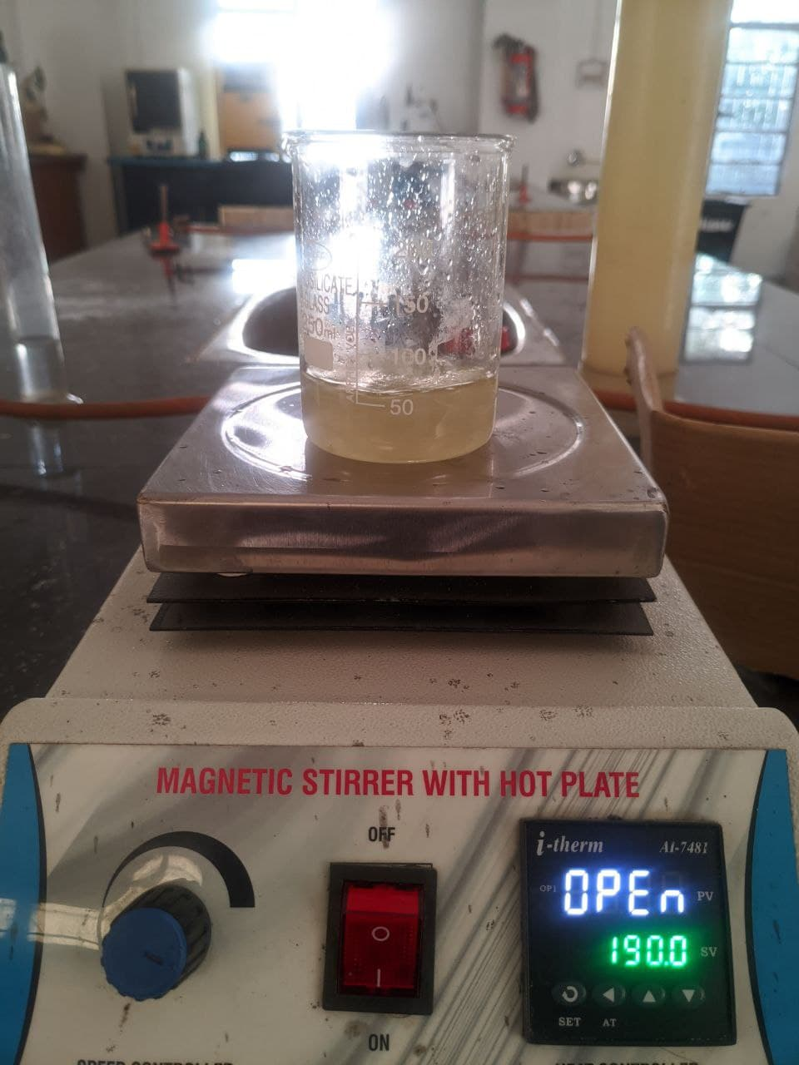

Fig 3.8 : Mixing of Nitrobenzene, MMT and chips using a magnetic stirrer

**3.7** the help of a Universal Testing Machine(UTM) to determine the Ultimate Tensile Strength of the film.

**3.7.1 Thermal Gravimetric Analysis (TGA)**

Thermal Gravimetric Analysis **(**TGA) was done for the neat film, 1% MMT added film and 2% MMT added film weighing at 7.03 mg, 7.38 mg and 8.789 mg respectively. The initial temperature was 30°C and final temperature was 700°C and the samples were heated at a rate of 10°C per minute.

**Characterization of The Film**

Characterization of the film was done to determine the properties of the film and to understand the impact of OMMT nano clay on the film. Thermal Gravimetric Analysis was done to determine the thermal stability of the films and consequently determine the decomposition temperature of the films. A tensile strength test was done on the film with

**3.7.2 Mechanical Test**

A tensile strength test was done on the PET sample to determine the stress-strain relationship of the film and to determine the Ultimate Tensile Strength of the film. It was performed using a Universal Testing Machine at Institute of Advanced Study in Science and Technology.

**CHAPTER 4**

**RESULTS AND DISCUSSION**

**4.1 Results**

In the results section the solubility of the PET chips were tested against various solvents at a temperature range of 25C to 160C. Non-Polar solvents such as Benzene, Toluene, Hexane, Ethyl Acetate showed more interaction with the PET bonds compared to the polar solvents such as Phenol and Nitrobenzene. Then we obtained the best set of parameters to fabricate a proper film. The impact of addition of OMMT in the fabricating process was analyzed.

**4.1.1 Interaction with Different Solvents**

PET is low density, semi-crystalline material and can maintain its structural integrity under the action of various organic and non-organic solvents. It was also found to be fairly heat resistant and can withstand temperatures of up to 175°C without deterioration of its properties which is a much higher range than what it has to withstand during its service life. Most of the popular solvents such as toluene, benzene, hexane, ethyl acetate, chloroform, DCM, DMSO, phenol, nitrobenzene could not dissolve PET at room temperature.

Non polar solvents such as toluene, benzene, ethyl acetate, chloroform, DCM could not dissolve PET at room temperature or even at higher temperatures. Some non polar solvents such as Phenol and nitrobenzene were able to swell the plastic pieces at around 100°C. Hence the bonds of PET have better interaction with polar solvents. Polar solvents are those that have large dipole moment and contain bonds between atoms with different electro negativities where a non-polar solvent have net dipole moment as zero.

Further the solubility of the chips were checked at 160°C. Although phenol swelled the chips at 100C, it could not dissolve the chips completely. Nitrobenzene completely dissolved the chips at 160C. Hence the interaction of nitrobenzene with PET is the highest among the polar solvents.

|  |  |  |  |  |  |  |
| --- | --- | --- | --- | --- | --- | --- |
| **SL No.** | **Solvent**  **(30 ml)** | **Time**  **(Minutes)** | **Melting at temperature (ºC)** | | | **Change in Texture** |
| **25** | **100** | **160** |
| 1. | Toluene | 20 | No | No | No | No Change |
| 2. | Benzene | 20 | No | No | No | No Change |
| 3. | Hexane | 20 | No | No | No | No Change |
| 4. | Ethyl Acetate | 20 | No | No | No | No Change |
| 5. | Chloroform | 20 | No | No | No | No Change |
| 6. | DCM | 20 | No | No | No | No Change |
| 7. | DMSO | 20 | No | No | No | No Change |
| 8. | Phenol | 20 | No | No | No | The plastic pieces swelled at 100ºC but did not dissolve even at 160ºC. |
| 9. | Nitrobenzene | 20 | No | No | Yes | The plastic pieces swelled at 100ºC and completely melted in the solvent at 160ºC. |

Table 4.1: Interaction of the chips with solvent

The film was kept under observation for 5 days. The solvent did not separate from the film at room temperature. Hence heating of the film had to be done just above the boiling point of PET to separate the solvent from the film.

**4.1.2 Optimum Parameters**

Parameters were adjusted to obtain a structurally sound film. The best film was obtained under the following parameters:

|  |  |  |
| --- | --- | --- |
| SL no | Parameter | Quantity |
| 1 | PET chips | 6 gram |
| 2 | Solvent | 40 ml |
| 3 | Temperature | 165°C |
| 4 | Heating time | 45 mins |

Table 4.2: Optimum Parameters

The temperature found optimum to separate the solvent from the film is 220°C with a heating duration of 90 minutes and castor oil can be used as a lubricating agent to easily separate the film from the petri dish.

**4.1.3 TGA of The Films**

TGA of the films were done to determine the thermal stability of the films and gauge the difference in thermal stability due to addition MMT as nano clay.

The TGA was done for a temperature range of 30°C to 700°C at the rate of 10°C per minute. The initial decomposition of mass due to increasing temperature happens at a lower rate till 100°C. The initial decomposition of the sample represents the presence of moisture in the film. Decomposition of film occurs at a steep rate between 400°C and 500°C. Hence, we can conclude that the material starts decomposing at around 400°C. The phase of decomposition from 500°C to 700°C represents the presence of ash content in the film. Addition of MMT increased the thermal stability of the film. The film containing the higher percentage of nano clay has lower overall thermal degradation and is marked in red.



**4.1.4 Mechanical Test of The Film**

The Ultimate Tensile Strength of the waste PET-based film was found to be 42.2. The Ultimate Tensile Strength of the virgin PET is 55. The film fabricated from waste plastics can be utilized for downgraded applications. 

Fig 4.2: Stress-Strain Curve of the PET Film

Here are the results obtained from the test:

|  |  |
| --- | --- |
| Sample ID Width | 5.00 mm |
| Sample ID Thickness | 0.180 mm |
| Yield Force | 38.0 N |
| Yield Stress | 42.2 MPa |
| Yield Strain | 3.07 % |
| Ultimate Force | 38.0 N |
| Ultimate Stress | 42.2 MPa |
| Ultimate Strain | 3.07 % |
| Break Force | 38.0 N |
| Break Stress | 42.2 MPa |
| Break Strain | 3.07 % |

Table 4.3: Results from the Mechanical Test

**FUTURE SCOPE**

We are primarily looking to use the film obtained in packaging industry. We have already determined the thermal stability of the film through TGA. The film can withstand temperatures up to 400°C and hence can be used in a wide range of packaging applications based on its thermal stability. We will be determining the tensile and mechanical strength of the film to gauge its resourcefulness in the packaging industry. We also aim to determine the increase or decrease in expenses due to use of nitrobenzene to melt the polymeric materials. We are currently awaiting the outcome of the mechanical tests.

**CONCLUSION**

From the current investigation, it is observed that waste PET bottles can be fabricated to useful nanocomposite films by using suitable solvent. The thermal investigation indicated that addition of OMMT increased the thermal stability of the film. The film containing the higher percentage of nano clay has lower overall thermal degradation. Thus we can conclude that Nitrobenzene is a suitable solvent. More possibilities are expected from further investigation.

**REFERENCES**

1. Ian Tiseo, 2022, "Global waste generation statistics and facts", Glo. Waste Gen., Vol.1, pp 1-50, Retrieved from https://www.statista.com/topics/4983/waste-generation-worldwide/#dossierKeyfigures
2. Garcia, J. M.; Robertson, M. L., 2017,“The future of plastics recycling. Chemical advances are increasing the proportion of polymer waste that can be recycled.”,Vol.358,pp 870−872.
3. Chidambaram, D Venkatraj, R Manisankar, 2002, "Solvent-induced modifications in poly (ethylene terephthalate) structure, properties and dyeability", NISCAIR-CSIR,pp 199-210.
4. A. H. Khan,G. M. Venkatesh, 1981, "Infrared spectroscopic study of solvent-induced structural changes in poly(ethylene terephthalate) film", Pol. Phy., Vol.19, pp 589-598.
5. Dr. Sabu Thomas, 2020, “Self-healing polymers: Synthesis methods and applications”, Nano-structures and Nano-Objects, Vol. 30, pp 47-83.
6. Joel R. Fried,2009, “Polymer Science and Technology”, Asoke K. Ghosh, pp 153-186.
7. Dr. Premamoy Ghosh, 2011, “Polymer Science and Technology”, Tata McGraw Hill Education Private Limited, pp 208-263.
8. Bruno A. Pulido,Ola S. Habboub,Sandra L. Aristizabal,GyorgySzekely,and Suzana P. Nunes, 2019, “ACS Appl. Polym. Mater”, Vol 1, pp 2379−2387.
9. Gang Wu,John A. Cuculo,1995, "Preparation of high performance PET fiber by solution spinning technique", APS, Vol. 56, pp 869-875.
10. Al-Salem S.M., Lettieri P., Baeyens J. 2009, "Recycling and recovery routes of plastic solid waste (PSW): A review",Waste Management, Vol. 29, pp 2625–2643.